Bret Peterson

BAN-530

5/3/2020

**Potential Property Investors Guide to Airbnb Amsterdam**

Airbnb has become a dominant force in the hospitality industry; opening a new market space by recognizing the demand for a “home away from home” feeling and the existing homeowners willing to rent their space. By making this market connection, Airbnb created a win-win situation for both customers and hosts. Customers win by having a larger variety of places to stay, thus creating cheaper prices, and Hosts win by being creating revenue from renting their properties.

Being that Airbnb has become one of the top choices for travelers when looking for accommodations; now is the time to invest in properties or convert current properties into Airbnb listings. For those entrepreneurs looking to delve into the Amsterdam Airbnb market, this analysis acts as a guide to both answer investment questions and reveal market opportunities:

**Questions and Revelations:**

* Year-over-year market growth as indicated by customer reviews
* Number of Airbnb by type: Total and by neighborhood
* Market summary by room type and neighborhood
* Number of host listings
* Are there any standout hosts? If so, what is their strategy?
* Bedroom, bathroom, and number of beds for an optimal listing.
* Overall Amsterdam market summary
* Minimum night stay requirements
* Pricing structure – Overall market summary
* Pricing structure by neighborhood
* Using average price verse median price and other host pricing tricks
* Rental availability by neighborhood
* Customer insight from sentiment analysis of listing reviews
* Overall market seasonality – when to raise prices and when to do repairs

**Analysis Software and Programs**

Due to the diverse nature of the data in the Airbnb Amsterdam Dataset, a variety of software programs were used to both explore the data and to present relevant investment opportunities:

* **Excel**
  + Being that the original datasets are in a CSV format; the initial data exploration and data cleaning were done within Excel.
    - Pivot Tables and Pivot Charts were used for exploratory analysis
    - In order to reference data from multiple spreadsheets, I used VLOOKUP and INDEX & MATCH commands.
* **Tableau** 
  + Due to the ease of creating a variety of graphs that have strong aesthetic values I used Tableau to do, exploratory analysis of the dataset and provide data visualizations for the following questions:
* Number of Airbnb by type: Total and by neighborhood
* Number of dates booked by type: Total and by neighborhood
* Revenue by Airbnb type: Total and by neighborhood
  + Bedroom configurations to maximize bookings
* Hosts with most properties: total and by neighborhood
* How does availability fluctuate throughout the year? Total and by neighborhood based on property types.
  + Peak/off times – increase rent/plan for repairs
* **R Studio**
  + R Studio has a variety of packages that allow for efficient and visually pleasing graphs for displaying the results of text data, quantitative text data, and sentiment analysis. I plan to use it to answer the following questions:
    - Use the “Widyr Package” to determine how keywords impact revenue:
      * Conduct sentiment analysis using customer reviews to determine what is important to the customer when staying at an Airbnb. I displayed this sentiment analysis with word bubbles and bar graphs.

The Airbnb Amsterdam Rental market has been booming over the past few years and now is the time to invest as even more vacationers are turning to Airbnb to book their vacation stay. As can be seen through the huge growth in customer reviews year-over-year; travelers, increasingly are sharing their praises from their Airbnb Amsterdam vacation experience.

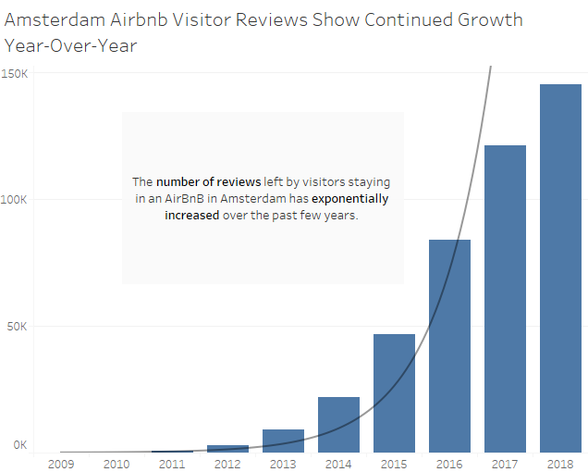

Being that only about 1 in 4 visitors leave a review, this is an underestimate of the actual growth in visitors choosing Airbnb as their “home away from home.”

If the huge market growth has your entrepreneurial sensors tingling, lets dive deeper into the current market structure for Airbnb Amsterdam. First, let us consider how many listings are currently listed to see where our best market opportunities lie.

A quick overview of the market shows that in 2018 there were only 18,219 Listings for Airbnb Amsterdam. Considering that the average days booked for the marketplace is 310 days, it seems that there still is a large market of vacationers looking to Airbnb to book their stay.

One interesting aspect of Airbnb for both vacationers and those listing the property is the opportunity to stay in a variety of “Room Types.” Airbnb breaks these options down into one of three choices:

1. Entire Home or Apartment
2. Private Room
3. Shared Room

To clarify the options, when choosing option 1, the person listing the property will not be staying at the property when the guests arrive. This option is by far the most popular option when looking at the current market structure, as well as, when considering what customers are looking for. The second option, Private Room, is less popular than the first option but offers investors who cannot afford a second property, the opportunity to earn revenue and vacationers a cheaper option. The third option, shared room, is the least popular amongst vacationers and has the fewest options as far as current listings. Shared room listings are exactly that, visitors expect to share a room with either other guests not in their party or with the owner of the residence.

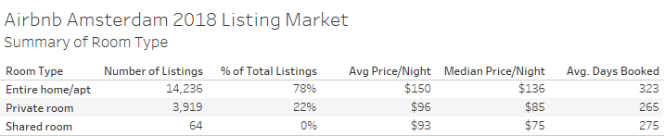

To gain a more granular view of the popularity of Entire Home/Apartment rentals in the Airbnb Amsterdam Market consider the following bar chart broken down by Room Type in each of the neighborhoods in Amsterdam.

As a potential investor, it is evident that Entire Home/Apartments is the trend that vacationers are most interested in.

Okay, so as a potential investor, you now know that Airbnb Amsterdam is booming with new customers and has seen exponential year-over-year growth. Now you are trying to decide if you are the right candidate to purchase a property to be listed as a rental on Airbnb. Perhaps you, like many others, are skeptical that there are a few hosts that dominate the entire playing field. With these “Super-Hosts” dominating the market, how can you make any money renting your property through Airbnb?

In analyzing the data of number of listings by host, an overwhelming majority of hosts only operate one listing.

Despite the fact that the majority of hosts only have one listing on Airbnb, there are a few exceptions of “Superhosts” who have more than 20 listings. Although these hosts are unique in their amount of listings, we can learn from their experiences to see what makes them potentially successful.

In analyzing the table above, one of the Super-Hosts seems to appeal to a more expensive audience than the other hosts indicated by the average listing price of $512/night and a cleaning fee of $152/night. By eliminating this host from the list, we can have a more accurate summary of the Super- Host’s listings.

After removing the Super-Host whose pricing structure was far different than the others, the average price/night for the Super-Hosts went down from $182/night to an average of $127/night. It is important to note the separate cleaning fee (average of $49/stay) that these hosts add to the final cost of stay for visitors. By adding the cleaning fee separately rather than including it into the price/night, the online listing gets an added boost in “perceived value.” Whether this tactic will impact rental interest in the future as renters become more aware of this hidden fee is yet to be determined, but for now acts as an added revenue source for Airbnb Hosts.

In examining the layout of the Super-Hosts listings, the average bedrooms rented is 1.4, but the average number of beds is 1.7. The higher number of beds compared to bedrooms suggests that visitors would prefer having more beds than more privacy during their stay. The average number of bedrooms being 1.4 and bathrooms being 1.2, also suggests that it is not necessary to have a huge house to list in order to start making money on Airbnb.

With the knowledge that the majority of Airbnb Hosts in Amsterdam only list one property, as an investor you can feel more confident that you too can make revenue from a rental property. By using the experience of the Super-Hosts with 20 or more listings, you can also have a decent concept of what the pricing structure for your listing should be and also how many bedrooms, bathrooms, and beds that vacationers are looking for when trying to book a place to stay. To even further increase your prospect of bringing in revenue with an Airbnb Rental property, let us dig deeper into the pricing structure of all Airbnb Amsterdam listings.

By analyzing the Airbnb Amsterdam market in its’ entirety, the average price/night went back up compared to the Super-Host average to an average of $152/night. Again, we can see the trend for Hosts to separately charge a cleaning fee to bring in additional revenue and keep the price/night at a perceived lower cost. It is also evident that most guests are looking to stay in a place with at least 2 beds but are less concerned on having more than one bedroom.

Another important detail to take note of is the average minimum nights required by hosts to stay at their listing. This tactic is another way that hosts can create a lower perceived cost/night when they require you to stay for more than one night. Not only can this be deceptive to a renter looking for a bargain, it is also confusing as a potential investor wanting to bring in revenue.

Only 15% of current Airbnb Amsterdam listings allow for a 1-night stay, meaning 85% of listings require vacationers to stay 2 or more nights before they can book their stay.

In order to have a more accurate reading as to what hosts are charging for each travelers’ vacation stay, I developed some calculations. The first calculation to consider is the “Minimum Nights Cost.” This calculation takes into consideration the price charged/night for a listing, then multiplies that cost by the hosts’ required minimum night stay, and then adds the hosts’ one-time cleaning fee to the total. By using this calculation, it becomes clearer what a customer is charged to stay at an Airbnb Amsterdam listing.

As you can see, when taking into consideration the “Minimum Nights Cost” calculation, the average revenue earned by a host in every neighborhood is increased substantially. As with most things, honesty is generally the best policy. As such, these deceptive pricing structures by current Airbnb Amsterdam hosts may catch up with them in the long run, but for the time being, vacationers are still flocking to Airbnb.

Hosts using different pricing structures to tack on extra fees may be deceptive to the customer, but as a potential host, it is equally important not to be duped by these tactics as to ensure a return on your investment. To avoid erroneous pricing, it is important to not only consider the most popular form of looking at central tendencies, the mean or average. Take into consideration the following chart calculated using average prices for listings in different Amsterdam neighborhoods:

Now take into consideration the following chart that calculates the same metrics, but instead this time the measure of central tendency used was the Median.

By using the median as a means for central tendency, it eliminates the extreme outliers that may skew an average towards being either too high or too low.

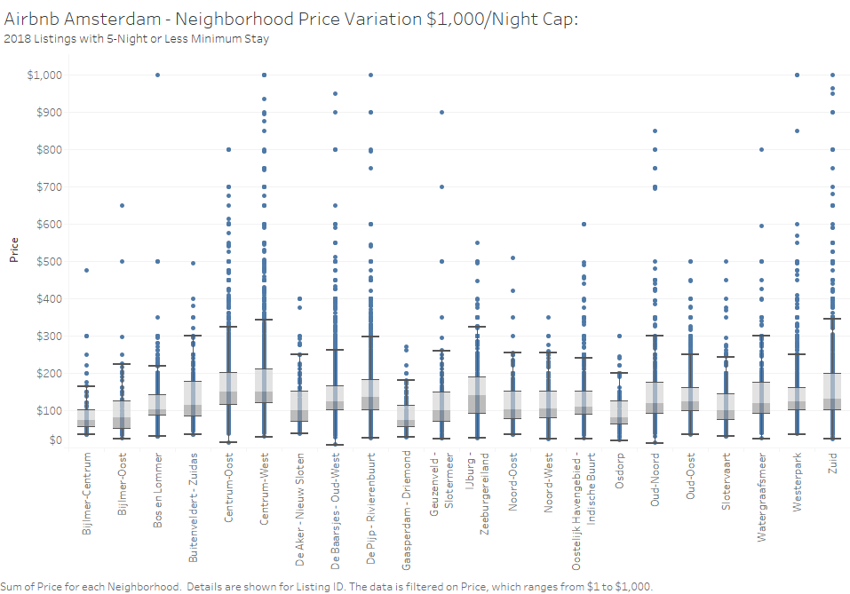To price your listing as accurately as possible, use the median price/night by neighborhood.

Not only is it important to determine your potential revenue by setting a price/night for staying at your listing; it is equally important to ensure that your listing is being rented out in order to obtain the revenue. To have a more accurate prediction of where vacationers to Amsterdam are staying analyze the following bar graphs broken down by neighborhood:

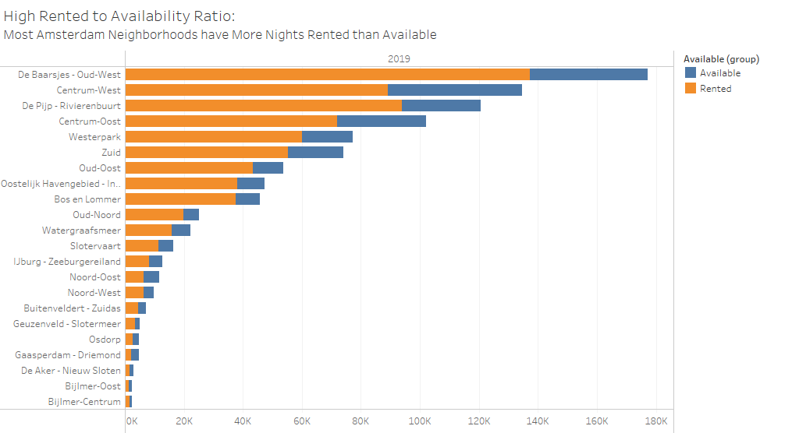

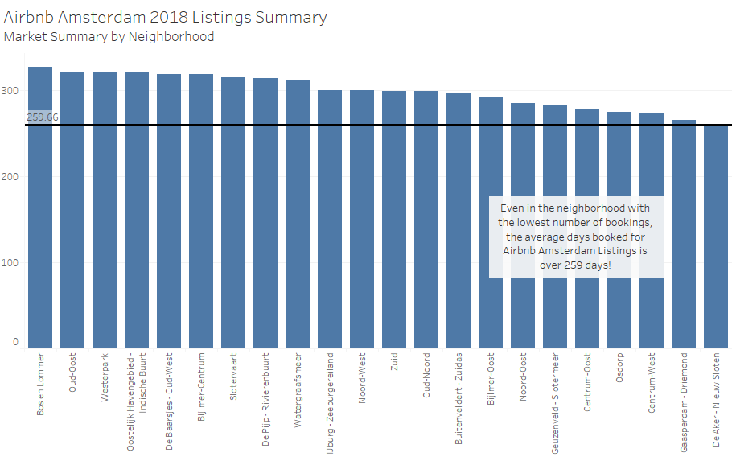

The above graphs scream great news as an investor, every neighborhood in Amsterdam has more days rented than available for the year 2019; however, there are a few neighborhoods who have a much stronger ratio as compared to others. Oud-Oost, Oostelijk Havengebled, and Bos en Lommer, all have many rentals and exceptionally low availability. This could suggest a demand in the market for more Airbnb Rental Properties.

An additional pool of information to also consider when considering purchasing a property to list on Airbnb is customer reviews. By analyzing both the frequency of words used in customer reviews and the sentiment of those words, you can find important clues to what amenities to include for a renter to have an optimal stay and also anticipate the expectations of those customers during their stay. The bar graph below represents the most frequently found words in customer reviews for both positive and negative sentiments.

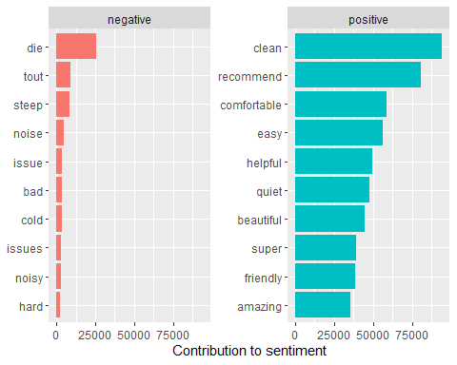

First, lets analyze the most frequently found words from negative reviews and hopefully avoid these things in choosing our investment property. Steep, noise, issues, bad, cold, issues, noisy, and hard are the most frequently used words found in negative Airbnb Amsterdam reviews that have pretty clear implications. For example, “steep” is often used to describe a price that is too high. Also, “noise” and “noisy” both imply that the customer stayed in a listing that had too much activity going on, most likely late at night. Likewise, “cold” can be interpreted as the listing not having the proper temperature regulation. “Hard” is often used to negatively describe a mattress. As such, we can infer that this customer may have been upset with the comfort of their bed.

After avoiding the negative sentiment words, let us analyze the positive sentiment words in hopes of gaining insight into things the traveler enjoyed about their stay. (Take note that there are far more words that imply a positive sentiment as compared to a negative sentiment. This is great news for a potential investor as we can assume that most customers were happy with their stay.) Words like, “clean”, “comfortable”, “quiet”, “easy”, “helpful”, and “friendly” all stand out as words with obvious implications. Clearly it is important for a listing to be “clean” for the customer to fully enjoy their stay. Likewise, “comfortable” and “quiet” both suggest that the renter appreciated a nice location away from all the noise of outside. Also, we can conclude that the host themselves has some sway on the customers overall experience through words like “easy”, “helpful”, and “friendly.”

Now that we know the price range, room/bed count, neighborhood seasonality, and customer expectations, it is next important to know what time of year is the most popular for rentals, as well as, what time of year is the least popular. During peak rental times, you are more likely to have your property occupied and thus you may be able to ask for a higher premium during these times.

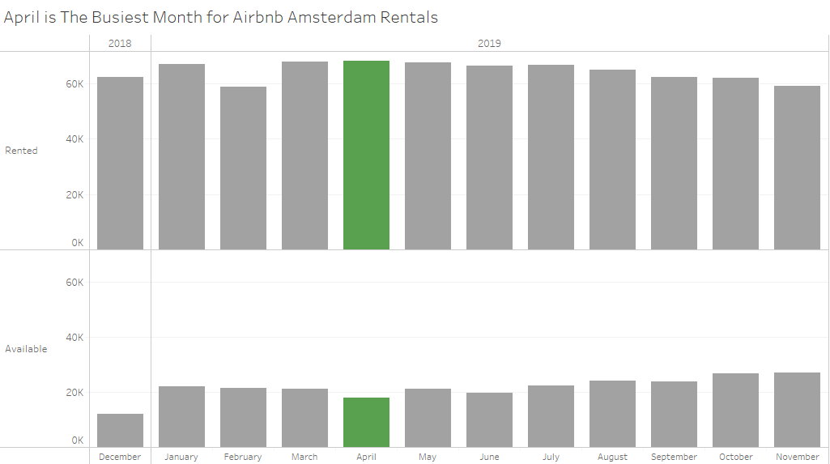

As can be seen in the graph above, April is the month with the least availability for Airbnb Amsterdam rentals. March, May, and June are also months that have high rented rates; however as can be seen on the lower half of the chart, the number of available properties is still somewhat higher than that of April.

Having this knowledge in advance can allow you to adjust your prices upwards for these months to ensure you maximize your rental revenue. This knowledge can also be useful when considering it from the opposite perspective. In other words, what months are the least rented? Knowing this can allow you to take advantage of slow months to do repairs in preparation for the “hot” season. This is also a great time for you as the owner to enjoy your rental property for more than the revenue it brings in. (Take advantage of this time to enjoy a few days off.)

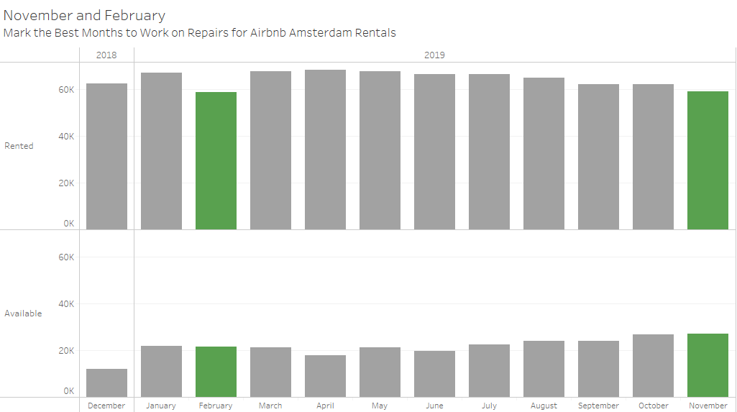

Numbers and reviews do not lie, people are interested in saving a buck and having a more “real” experience on their vacation and as such are turning to Airbnb instead of the chain Hotels. Will you have your property ready to be rented or will these customers have to turn to someone else’s investment. The choice is yours.